1. Add a maven dependency and its related repository URL.

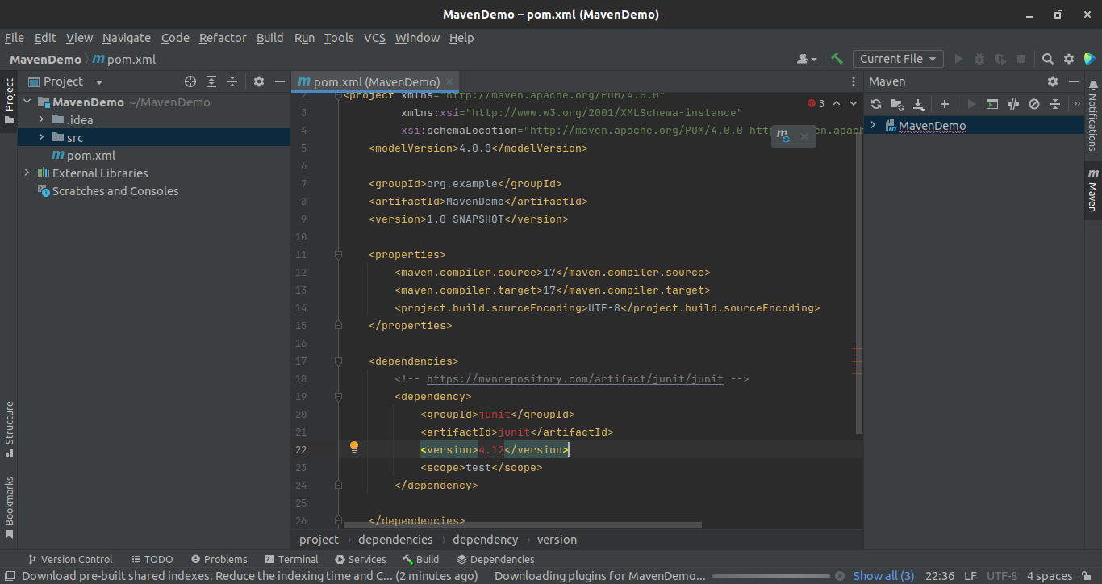

2. Add a new repository in the pom.xml and use its dependencies.

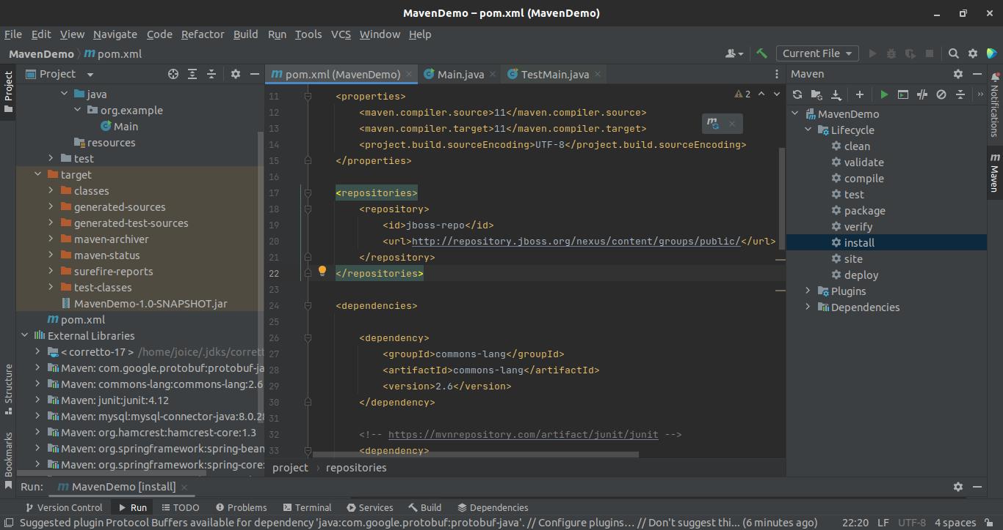

3. Using JAR plugin, make changes in the pom.xml to make the jar executable. Using java -jar JAR_NAME, the output should be printed as "Hello World".

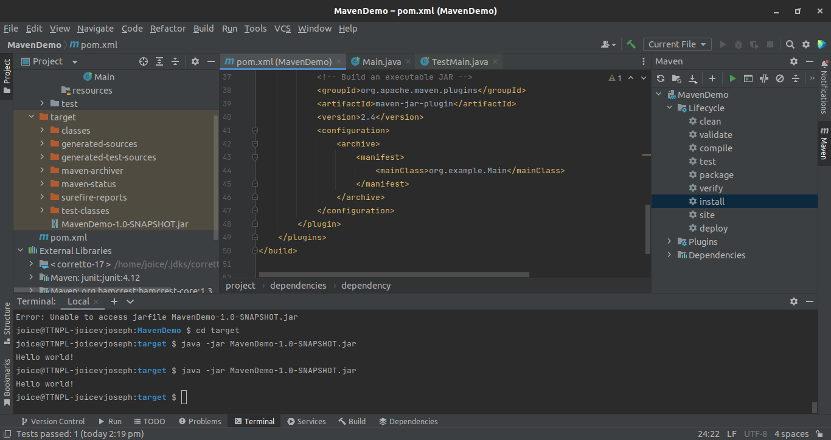

4. Differentiate between the different dependency scopes: compile, runtime, test, provided using different dependencies being defined in your pom.xml.

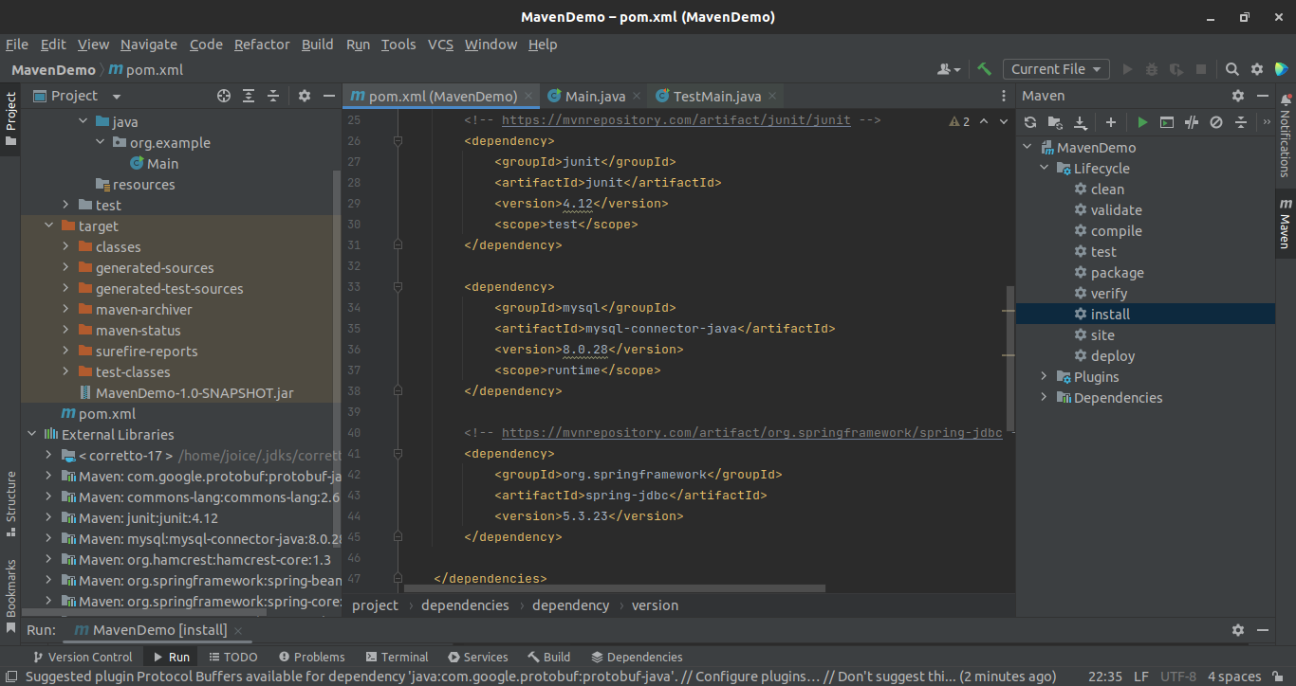

5. Create a multi-module project. Run package command at the top level to make jar of every module.

